# Lab 03 – Creating ER diagram using MySQL

This Lab relates to the following Course Learning Requirements:

CLR 1: Follow lab policies and procedures for etiquette, software licensing requirements and lab submissions

CLR2: Use workplace tools to model database design using ER diagrams

CLR3: Create database backups

Objective:

The objective of this lab is to get used to MySQL workbench modelling tool and create the backup of the model.

# Pre-Lab Instructions:

1. Read Module 3
2. Watch [https://www.youtube.com/watch?v=WEVEABUVRBI](https://can01.safelinks.protection.outlook.com/?url=https%3A%2F%2Fwww.youtube.com%2Fwatch%3Fv%3DWEVEABUVRBI&data=04%7C01%7Ccloutir%40algonquincollege.com%7C471d844800854951771008d889acba30%7Cec1bd9240a6a4aa9aa89c980316c0449%7C1%7C0%7C637410722241401334%7CUnknown%7CTWFpbGZsb3d8eyJWIjoiMC4wLjAwMDAiLCJQIjoiV2luMzIiLCJBTiI6Ik1haWwiLCJXVCI6Mn0%3D%7C1000&sdata=DSyZtKMT4n14oTD0K9tt5nz%2B0kUJn0kwYMAO5NxXiqw%3D&reserved=0)

**Lab Tasks:**

1. Go to MySQL workbench. To know the steps to open workbench, go back to Lab 01.
2. Click File -> New Model -> Add Diagram
3. Once you have the diagram screen open. You should connect to the database.

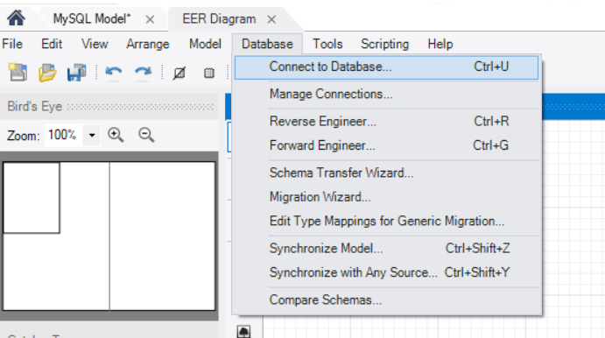

1. Left toolbar displays different items that can be used to draw model.

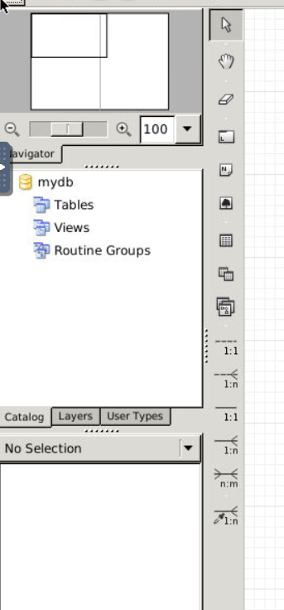

1. Click Place a New Table then click anywhere in the Diagram, do this three times.
2. Double click each table and rename them to car, customer, car_customer.
3. In the three tables define the columns as follows
   * Car – idcar, model name, model year, price.
     1. idcar (INT,PK, NN, UN, AI)
     2. model_name (VARCHAR(45), NN)
     3. model_year (INT, NN)
     4. price (DECIMAL, NN)
   * Customer- customer id, name, phone, address
     1. idcustomer (INT,PK, NN, UN, AI)
     2. name (VARCHAR(45), NN)
     3. phone (INT, NN)
     4. address (VARCAHAR(400), NN)

The image below shows the icons to create the relation between above two tables.

1. Click 1:N and then click the car_customer table and then car table.
2. Click 1:N and then click the car_customer table and then customer table.

(See below on the image for 1:N button)

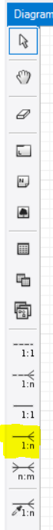

* + Car Customer – car customer id, car id, customer id, date car bought.
    1. car_customer_id (INT,PK, NN, UN, AI)
    2. rename the id created from car table to idcar
    3. rename the id created from car table to idcustomer
    4. date_purchased (DATE, NN)

1. After you have your table created. Save the model and name it as FirstName_LastName_Lab03.mwb
2. Export it as FirstName_LastName_Lab03.png
3. Your lab is to be submitted with FirstName_LastName_Lab03.mwb and FirstName_LastName_Lab03.png

(example: Vishal_Arora_Lab03)

**Lab Grading Rubric (3%)**

|  |  |
| --- | --- |
| Lab Submission (correct file names) | /1 |
| Correct column names | /1 |
| Correct relation and solution | /1 |
| Total Points | /3 |
| Comments |  |